Charity Number: 1164985

___________________________________________________________________________

LEICESTER A46 EXPRESSWAY - The Road to Ruin

A CPRE Perspective

March 2019
___________________________________________________________________________

Introduction

Leicestershire Councils want to build an expensive new road round the South and East of Leicester called the A46 Expressway. It would probably be a dual carriageway with grade separated junctions which would cut through High Leicestershire and be linked to 38,000 new houses built in new settlements circling that side of Leicester.

The first of those new settlements is already being promoted at Whetstone Pastures, South of Leicester, which would, along with a massive new Logistics Park, straddle the M1 at a new Junction 20a.

The Councils present the road as the lynch pin to their Strategic Growth Plan, which would guide development in the County from now until 2051.

The road would become part of the National Trunk Road Network and is being promoted by Midlands Connect, a quasi-public but largely unaccountable body, as part of an A46 Corridor from Gloucester to Immingham in Lincolnshire.

The cost of the road would be hundreds of millions of pounds and would, inevitably, need public funding. It would be likely to take years to develop and to gain planning permission, however, the longer they work on it the more hardened are the proposals likely to become.

The route of the A46 is set out in diagrammatic form below, with an indication of where housing might go, but there is currently no definitive line on a map.

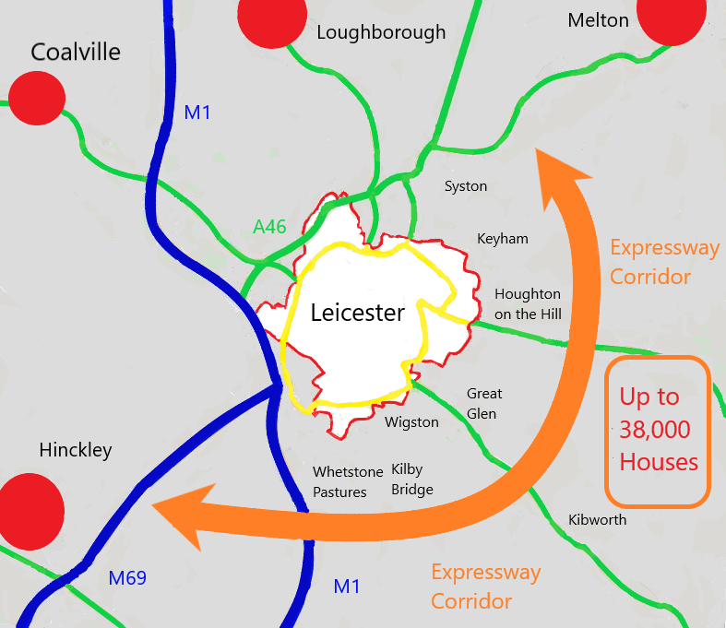

A46 Expressway Corridor with indicative housing areas

CPRE believes the proposals are fundamentally flawed because:

- The road will not resolve the transport problems around Leicester. In the longer term it will encourage increased traffic and thus exacerbate the problems.
- The road will act as a catalyst for housing to be built in open countryside along the route while, at the same time, adding to traffic problems going into Leicester.
- Midlands Connect are exaggerating the benefits of wide scale road building along the A46 corridor.

CPRE also questions the proposed level and location of housing:

- The level of housing needed in Leicester is more modest than is being suggested.
- Councils should be maximising opportunities for development within Leicester and other urban areas.
- New settlements around the edges of the city would not provide the right kind of housing for the county in the right place.

CPRE warns that, if the current proposals are taken forward, they would:

- Do great and irreparable harm to the high-quality countryside around the East of Leicester.
- Increase congestion within and into Leicester and fail to provide public transport alternatives to car travel.
- Undermine Sustainable Development goals, including reducing Climate Change.

CPRE calls on the Councils:

- To set out a strategy to address the transport issues in Leicester which aims to reduce the level of car dependency in and around the city based on prioritisation in this order:

- Firstly, public transport Interventions.
- Secondly, specific improvements on existing roads.
- Thirdly, (and only if still needed,) providing limited new road capacity to compliment proposals in (a) and (b).

- To redirect their policy towards increased housing within Leicester and other towns to support wider urban regeneration.
- To set out policies to protect the countryside of High Leicestershire (East of Leicester).

The Transport Issues Round Leicester

Leicester currently suffers from congestion problems, which are evident mainly in the morning and evening peaks. This is not unusual for cities where there is a significant amount of commuting into the centre. The congestion is evident on many of the radial routes, including the existing A46 from the Hobby Horse junction round the West of the city to the M1.

The problem is not simply on one route, it is a network problem which requires solutions across the whole network.

To an extent all congestion problems are self-correcting. That is to say, there is a limit to the congestion people will tolerate over an extended period. Congestion will lead to changes of behaviour and influence decisions on where people live and work. But equally, if pressure is released by new road capacity, that will encourage traffic growth, move problems around and may make them more intractable in the longer term.

The majority of cars and lorries using the existing A46 are either local or are leaving or entering Leicester. This will be particularly true in the congested peaks. So even if the Expressway reduced the long-distance traffic on that route, any released capacity would be taken up with an increase in local usage.

This could actually make the road function less well, as there would be more diverging traffic leaving and entering at junctions, reducing the overall free-flow capacity. It could also increase congestion problems on routes into Leicester from the A46, where much of the increase in traffic would be heading.

The only long-term way to reduce congestion on the Leicester network is to invest in upgrades to public transport and to support land use patterns which ensure more people either live in the city or have access to public transport into the city.

In the short term it may assist to invest in specific improvements at junctions along the A46 and other pinch-points around the city. There may even be a case for some small -scale road building. However, these do not present long term solutions as there will always be parts of the network which cannot be improved and so congestion will re-emerge elsewhere.

Why the Expressway Won’t Work

The Expressway is the antithesis of this approach. To justify it the Council, along with Highways England, rely on a predict and provide approach to future traffic growth. They use Government predictions of traffic growth which have consistently proved to be exaggerations and which are inconsistent with the leveling off of the rise in traffic in recent years.

The reasons for this leveling off are complex, but one factor is changes in the attitude of younger people to car ownership. Whatever the cause, the result is that the level of traffic predicted on the Leicester network, and the resulting congestion, without the Expressway being built are likely to be exaggerated.
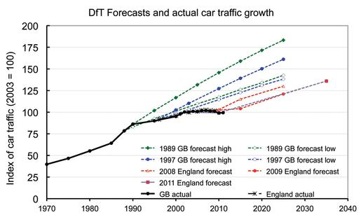

Comparison of DfT forecasts and actual traffic growth

However, there is strong evidence that building new road infrastructure increases traffic. This is partly because of extra traffic that would result from new developments along a route, and also because a new road facilitates additional traffic growth, for example, encouraging commuters to travel from further afield.

Building a new A46 Expressway round Leicester would facilitate additional traffic growth. It would encourage commuting into Leicester from further away, with traffic using the radial routes from the Expressway into Leicester. Congestion on these routes would inevitably increase as a result of this new road, even if the road itself could be kept free-flowing despite all the development around it.

Despite these obvious facts, Leicestershire County Council has failed to take account of additional traffic that would be generated by building the road in its assessments and has not, to our knowledge, undertaken work to assess whether the radial routes from the Expressway could cope with the additional pressures the road (and the adjacent housing) would bring.

Instead they undertook a study which modelled traffic growth beyond the Expressway proposal to justify further road capacity increases in the future, all of which would add to the problems on the constrained routes entering Leicester.

This approach which fails to address the fundamental flaws in the approach, but pushes them down the line in the unsubstantiated hope that something in the future will resolve them, shows a fundamental failure to future-proof policies, both in terms of the economic and ecological future of the county.

Midlands Connect and the A46 Corridor Myth

The proposals for a Leicester Expressway are also being promoted by Midlands Connect, which is supported by Councils across the East and West Midlands.

Midlands Connect’s remit is specifically to examine only inter-urban travel by road and rail and is tasked only with improving performance on those links. As a result, it cannot examine holistically the traffic problems in and around Leicester and other towns and cities.

This has led it to adopt a traditional ‘lines on the map’ approach to road building and to manufacture the concept of a key national economic corridor along the A46 from Gloucester to Immingham in Lincolnshire, while producing little evidence of how much business along the corridor rely on the route or how many people make long distance journeys along the corridor.

A number of unsubstantiated conclusions are included in an Enhanced Business Case for the Route. These are set out by using statistics and making wide ranging claims about the traffic benefits of improving the route to Expressway Standard. None of these can be independently tested because the technical support work is not in being kept out of the Public Domain.

Midlands Connect assures us that when they publish the next stage of this work in the summer of 2019 it will include detailed transport and economic modelling, something CPRE will scrutinize in due course.

One thing we do know is that their modelling so far has not taken account of additional traffic generated by building new roads, as explained above, so their claims of improved journey times are likely to be unrealistic. We also know that the economic benefits will largely be based on those travel time savings, many of which will be so small they will not create genuine economic benefit or will be overtaken by the new traffic generated by the road itself.

Moreover, their analysis solely seeks benefits on the route itself. Whereas, in reality, those gains will be undermined if the local roads clog up with additional traffic generated by the new road building proposals.

Of course, Leicester, like other urban areas along the A46, does create congestion on the route, but, while Midlands Connect is proposing welcome improvements to the rail network into Leicester, its officers have not, so far as we are aware, considered whether managing traffic congestion into Leicester would be a better way to address problems on the A46 in Leicestershire rather than building a new route, which will inevitably, itself, become congested.

The only long-term solutions to Leicester’s problem will come from a network approach, including a mixture of public transport investment, support for walking and cycling, traffic management, fiscal mechanisms, planning control and small-scale junction improvements.

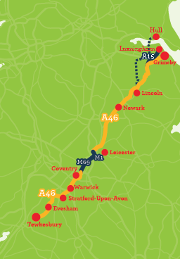
Leicestershire

- Potential for
Leicester Southern/Eastern bypass

- M1 Smart Motorway

- Upgrading
Leicester
Western bypass

- Improving Hobby Horse interchange at Syston

Midlands Connect’s A46 Corridor Map
The Housing Problem in Leicestershire

How Many Houses Are Needed?

The Strategic Growth Plan sets out the number of houses Leicestershire Councils believe they need to build by 2051. This is divided between the years up to 2031 where they need to plan for housing and for longer-term assumed housing growth up to 2051.

The number of houses, which they say they need, is based on projections of the growth of future housing need. This is predicated on the assumptions about a growing population and a continued reduction in the average size of each household.

The Government then requires councils to add a percentage extra, supposedly to make houses more affordable, although there is little evidence that such an approach works.

The result of this arithmetic is the claim that Leicestershire, including the City of Leicester, needs just over 96,000 new homes by 2031 and 90,000 more by 2051.

These figures are purely theoretical and rely on the assumption that past trends will continue, even though there is good reason to believe they will not. In particular, over the last decade household size has not fallen as expected. Some of this may be due to the recession but there are other underlying economic and social trends, such as divorce rates and when young people move out of the family home, which will also impact on the figures.

That is why the most recent independent projections by the Office of National Statistics, suggest the overall number of houses needed in Leicestershire is not nearly as high as suggested even up to 2031. In the City of Leicester, particularly, the latest evidence is that only 17,000 houses are needed, not the 33,000 the Growth Plan assumes.

Beyond that the need is likely, if anything, to further level off but, bizarrely, the Growth Plan assumes an unlikely trend continues for another 20 years, with little evidence and no requirement from Government to do so.

How Many Houses Can Be Provided?

The Strategic Growth Plan also sets out how many houses the Local Authorities believe they can provide. They conclude there are sufficient houses in the pipeline up to 2031 from existing Local Plans.

They go on to set out notional targets for housing from 2031-2051 and identify how the extra 90,000 houses could be split up. This includes 39,000 on the route of the Expressway, mostly in Charnwood, Harborough and Blaby.

This is a highly problematic approach.

The first problem is that there is no up to date evidence on how much housing Leicester City can actually provide. Nor is it clear that the city is maximizing the use of its brownfield land.

We understand that Leicester will produce evidence on housing supply when it starts to develop its local plan but that is still at least a year away and will have to go through the local plan process to be tested.

A second problem related to that is that all local areas, and particularly cities, benefit from additional housing on windfall sites that cannot be predicted and, therefore, cannot be allocated in Local Plans.

It is highly likely that some sites currently in industrial, retail or leisure use will come forward in the city for housing or for mixed-use developments over the next twenty years and these also need to be factored in.

The third problem is that there are areas within Leicestershire where the SGP recognises that regeneration is desperately needed, such as Coalville and Hinckley. While it is partly true that current economic and social climate are hampering that, it is also likely that proposals to concentrate development elsewhere will hamper that process.

It is almost inevitable that all these factors will mean that the availability of land, particularly brownfield land in twenty years’ time will be greater than can be anticipated now.

Where Should We Be Building?

It is important to stress that we need to build sufficient homes to accommodate the needs of people in Leicestershire. However, exaggerating how many homes are needed will create its own problems.

Over-allocating housing land does not mean more houses are necessarily built, it does mean that housing is allocated on green field sites in locations which are less accessible and more reliant on car travel.

Targeting where houses are built allows emphasis to be placed on regenerating urban areas and on supporting local services. And, while there are other factors involved, targeted house building can also help ensure the houses that are built meet the needs of new households, in particular first-time homeowners and the growing numbers of elderly or infirm. Wherever houses are built CPRE believes it is essential that the right type of accommodation is provided address those needs.

In conclusion, we do not believe the evidence supports the need for large scale housing development along the line of the A46 Expressway. To do so would almost inevitably lead to housing development in the wrong place at the expense of urban regeneration.

It’s the Planet, It’s the Countryside

CPRE is also particularly concerned about the impact of the proposals on the countryside around Leicester and the wider impacts on environmental sustainability in the county. The Strategic Growth Plan includes a pillar to protect and enhance the environment but instead of doing so actually defines the landscape as a constraint to be overcome.

Although the area round Leicester does not enjoy the added protection of Green Belt status, it does perform the important function of containing urban sprawl and encouraging regeneration. There are also areas of high landscape value as well as ecologically valuable and heritage sensitive sites.

The route of the A46 passes many attractive rural settlements through an area of very high landscape value. High Leicestershire, in particular, is an area of undulating arable and pasture fields intersected by a network of narrow country lanes, tracks and footpaths. It is interspersed with woodlands, hedgerows and small attractive villages, hamlets and farm buildings.

Because of its topography it would be hard to mitigate the impacts of a major road through the area or lessen the presence of new housing estates. CPRE are extremely concerned that what seems such a valuable landscape on the outskirts of Leicester appears to be so little appreciated in the plans being put forward.

More widely, the impact of the proposals on pollution, climate change and other wider environmental impacts do not appear to have been adequately considered. Given the increased car usage likely to result from these proposals it is hard to see how they can do anything other than increase emissions.

So, how do we improve transport in Leicester?

There are then four elements to a package to address Leicester’s Transport Issues.

- There needs to be a greater focus on regeneration within the city which concentrates more development in the city rather than on greenfield development in the countryside.
- There needs to be a step-change in public transport provision, along with walking and cycling prioritisation, within Leicester.
- There need to be targeted junction and traffic management improvements on the existing network to address short-term congestion issues.
- Some limited additional road capacity (particularly between the M69 and A46) should be analysed but only if it supported the changes set out in Points 1-3.

___________________________________________________________________________

CPRE LEICESTERSHIRE

Contact Details

Tony Stott, Chair, CPRE Leicestershire SGP Task Group
Caroline Pick, Trustee, CPRE Leicestershire
Rick Hoyland, Trustee, CPRE Leicestershire

Web: http://www.cpreleicestershire.org.uk/

Email: info@cpreleicestershire.org.uk

___________________________________________________________________________

https://www.llstrategicgrowthplan.org.uk/the-plan/stage-three/
https://irp-cdn.multiscreensite.com/0842dc3a/files/uploaded/Developer%20Prospectus.pdf
https://www.midlandsconnect.uk/publications/a46-stage-one-corridor-study-summary-report/
https://www.llstrategicgrowthplan.org.uk/the-plan/stage-two/developing-the-evidence-base/strategic-assessment-transport-impacts/
http://publications.naturalengland.org.uk/publication/5911470780973056?category=587130

